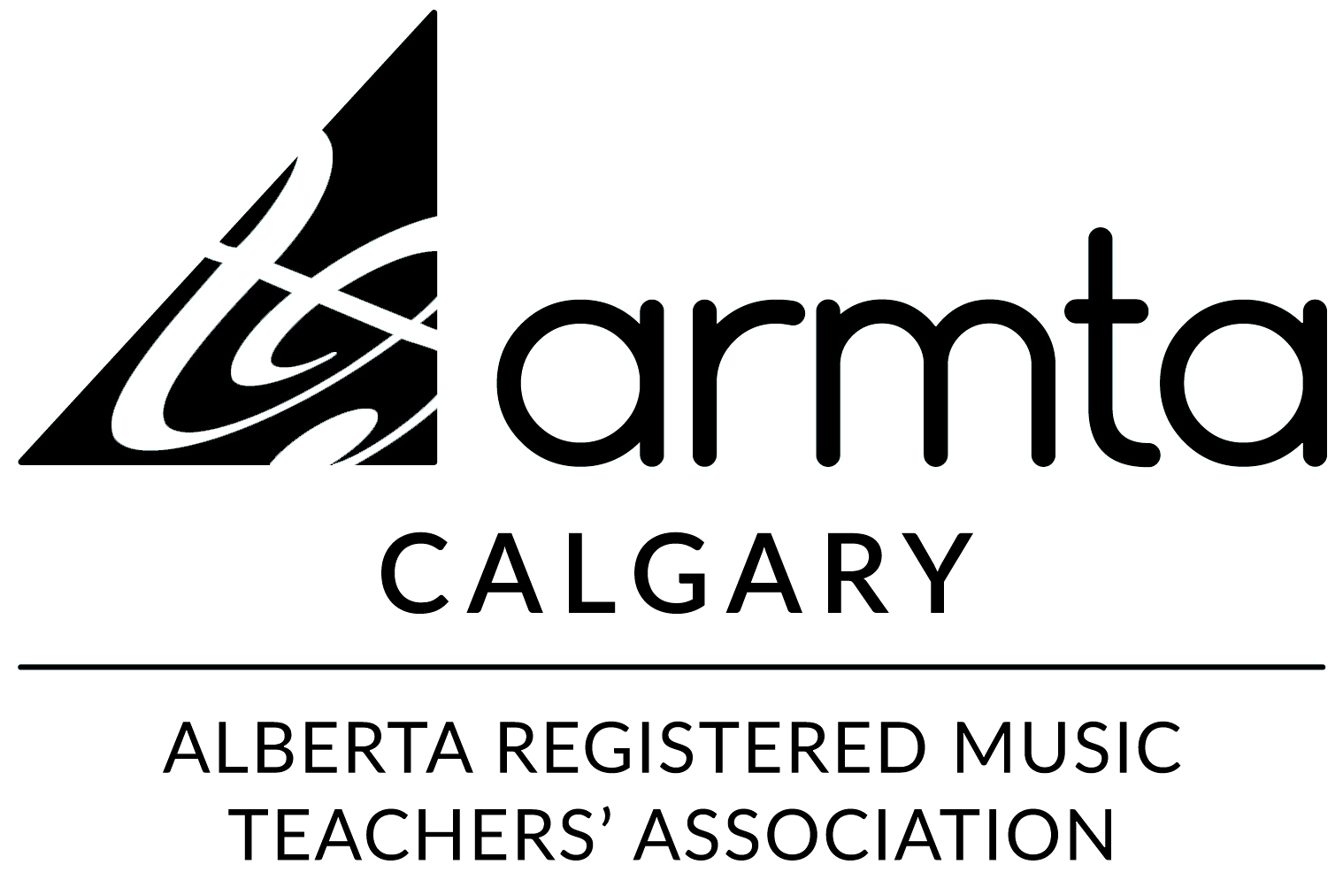
NORTH STUDENT RECITAL
Saturday, November 26, 2022 at 2:00 pm
St. David’s United Church 3303 Capitol Hill Crescent NW

Caroline Shan Dance (Kabalevsky)
Jakob Springett Stealing a March (McIntyre)
Hailey Ha The Naming of Cats (Eliot)
Alexandra Chkolnikova The Juggler (Faber)
Safia Rahmat The Rising Sun (Telfer)
Olivia Chung Someone (Archer)
Eli Seeliger George, Who Played with a Dangerous Toy (Belloc)
Tabitha Ma Cha-Cha (Mackay)
Emily Yan Prelude (Gliere)
Ethan Jiang Vanished Days (Grieg)
Evia Seeliger The Elf and the Dormouse (Herford)
Kevin Wang Speedy Car (Nakada)
Emilie Ha Myles and the Monster Outside (Dowding)
Andy Zhu Sonatina in F+ (Diabelli)
Audrey Lan Gentle Breeze (Bender)

Thank you to today’s participating ARMTA Calgary Teachers:
Natalie Brodsky, Gloria Chu, Frances Ewington, Nadia Khlynovskaya, Josée Robitaille

Thank you to today’s voice, violin, speech arts & piano performers.

