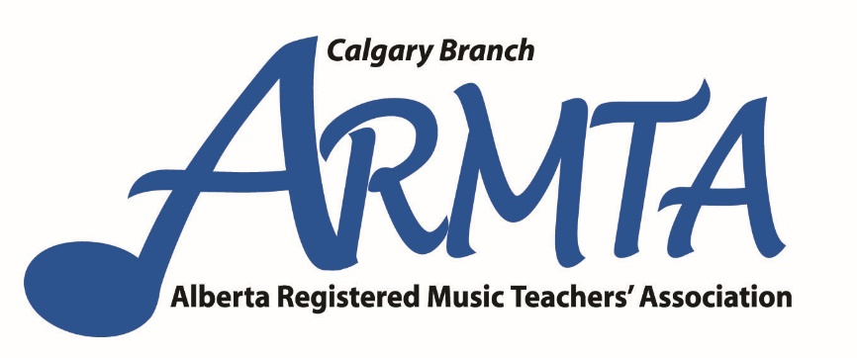

With the assistance of provincial association

presents

**Dr. Magdalena Adamek**

assistant professor/collaborative piano

Virginia Commonwealth University, Department of Music, Richmond Virginia

On an Alberta tour

(Edmonton, Calgary, Lethbridge)



**Sunday 2017 May 7 1:30 – 4:00**

**All Saints Lutheran Church 380 Midpark Blvd SE (near MacLeod Trail)**

Part I

Strategies for teaching young students to play with beautiful tone:

developing natural habits from the beginning.

Part II

The art of collaborative piano playing.

Participation is limited to the first 50: Register with your name and email address at [soundsofmusic@shaw.ca](mailto:soundsofmusic@shaw.ca) or text 403 542 9657

Event is free for ARMTA Calgary Branch members. Non-members are $10 payable at event. http://armta.ca/prov/wp-content/uploads/2015/10/My-Music-Staff.pnghttp://armta.ca/prov/wp-content/uploads/2015/10/Westland-2016-logo.jpg

DESCRIPTION

In the first part, I plan to address strategies of teaching a young student to play by arm weight and developing a grasp of a high quality sound. As an active pianist and instructor, I have found this endeavour challenging as students (usually prompted by their parents or peers) tend to rush through their repertoire. They often don't reflect on the fact that the more natural habits they establish in the beginning, the more they are able to achieve the desirable level of comfort in playing. As a result, they often substitute the quantity for quality.

I will demonstrate that for such students 'more' may sometimes mean 'less' in the long term. I will also show that the right gesture, combined with active listening, is the key to obtaining the sound one truly wants.

The second part of the workshop will be devoted to the art of collaborative piano playing. This can be done in a masterclass format, e.g., students bring their partners (violinists, singers, cellists, flutists, or another pianist-duo partner), or a lecture directed towards piano teachers and piano students. If a lecture format is chosen then I plan to discuss the role 'pianist-accompanist' or 'the pianist-collaborator' in today's musical world, and the contribution that collaborative playing makes to the musical development of students (aural awareness, musicality, sound quality, compassion).